A local technology company that makes complicated technology solutions simple for residential homes and ranches in the Santa Ynez Valley.

SYVConnectedHome

Welcome to Connected Home for the Santa Ynez Valley

Bringing the humanity into solving technical problems in your home

At Connected Home, we are dedicated to one thing: Delivering simple solutions to common technical problems for homes and ranches in the Santa Ynez Valley. If it doesn't improve your experience or simplify your life, we don't offer it. Ready to get started?

As local residents of the Santa Ynez Valley for more than two decades, we understand the things that make our homes and area unique: The wide open spaces, early morning walks in the foothills, the afternoon wine tasting outings, trips to the beach with family. And at the end of the day, when we come home, it's our moment to take a deep breath and appreciate it all. It's where we've been planted.

And just because we've left the city, doesn't mean we've left our connection to the world. We reach out to our parents or kids; we watch our favorite shows; we listen to our favorite newscasts or read our newspaper online; We appreciate and rely on the convenience that technology brings to our lives, and most often isn't even noticed, until it doesn't work. That's where we come in: We design, install and support robust systems, based on industry-leading software and hardware platforms. Each solution is unique to you, with the goal of enhancing your living experience with a focus on simplicity and reliability.A person standing on a rock

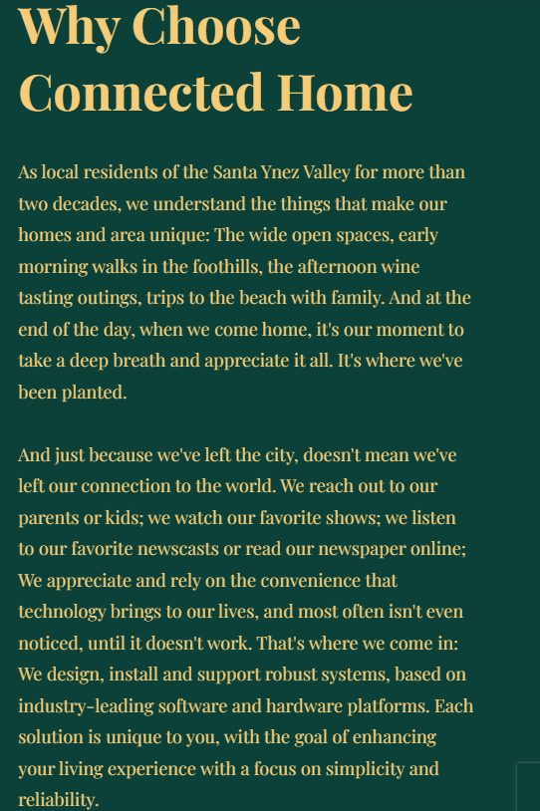

At Connected Home, we offer a range of comprehensive solutions to common technical problems in the Santa Ynez Valley. including internet connectivity optimization, transitioning from cable TV to streaming TV, enhancing cell coverage throughout your home, and introducing intelligence to your thermostat, plugs, appliances and security system.

Additionally, we offer a complete solution to your ever-growing PG&E power bills including solar panels, inverters, battery backup systems and generator sets.

Step 1: Phone Meeting

Our first conversation will be an initial, no-cost phone call to understand what you're trying to fix or solve for

Step 2: Personal Meeting

If we think we can help, we'll schedule a meeting in your home to expand that conversation and dig deeper into the details of the problem in the context of your unique home and environment. The cost of the fixed-price initial consultation fee will be applied to your final solution, should you decide to move forward.

Step 3: Proposal Review

With that thorough understanding, we'll send you a proposal with all the details for you to understand the solution and make an informed decision.

Step 4: Schedule the Work

Once we are in agreement on the work and expected improvement to your quality of life, we'll schedule the work and get it done.

​